**Reconnaissance Report**

Step 1: We use <dig command querying DNS servers to retrieve information such as domain name and ip address.

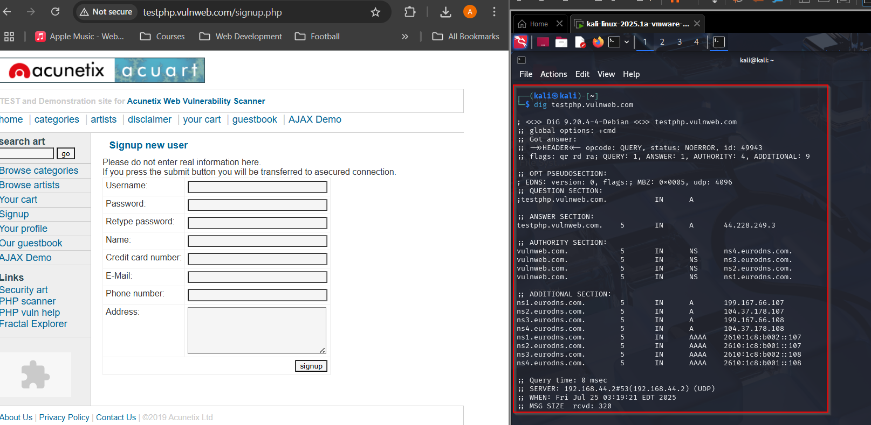

Step 2: Search <dnsdumpster.com> to find subdomains of this page if any

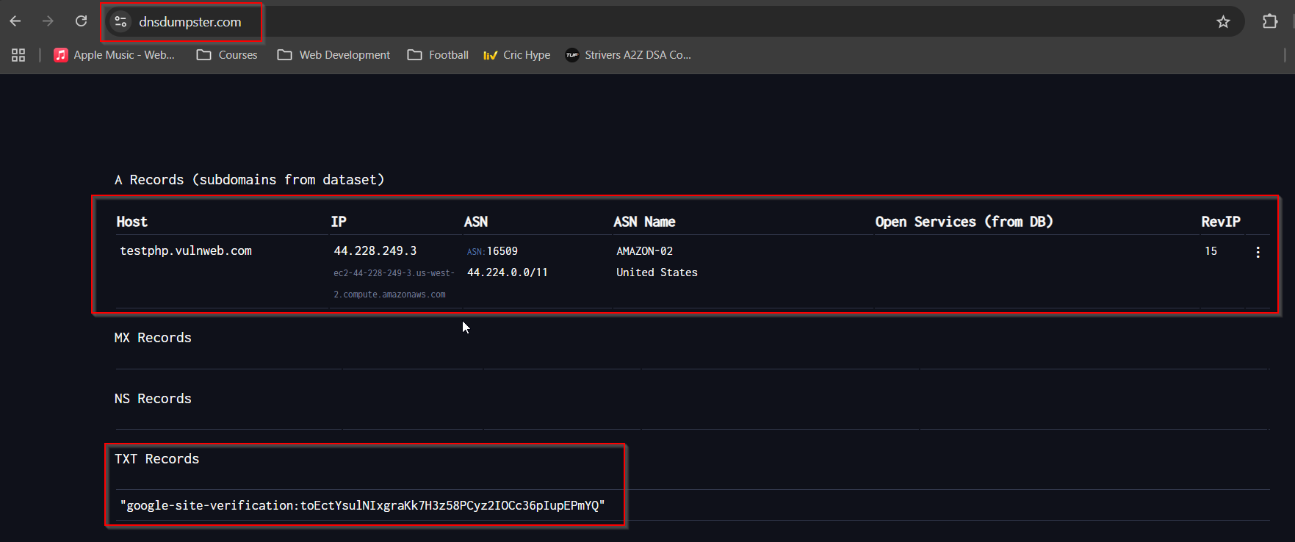

Step 3: Send ICMP echo packets using <ping> to check if the ip address is reachable and find the round-trip time for the packets

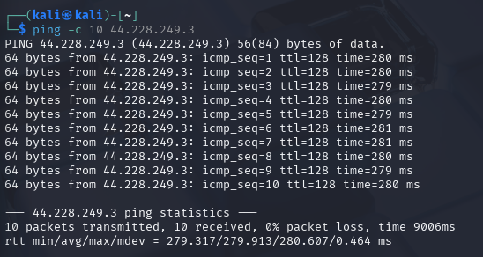

Step 4: The username is taken from the credit card details which are randomly generated at <neapay.com/online-tools/credit-card-number-generator-validator.html>

Step 5: The password is randomly generated from <avast.com/en-in/random-password-generator>

Step 6: Temporary Email Address is generated from <temp-mail.org/en>

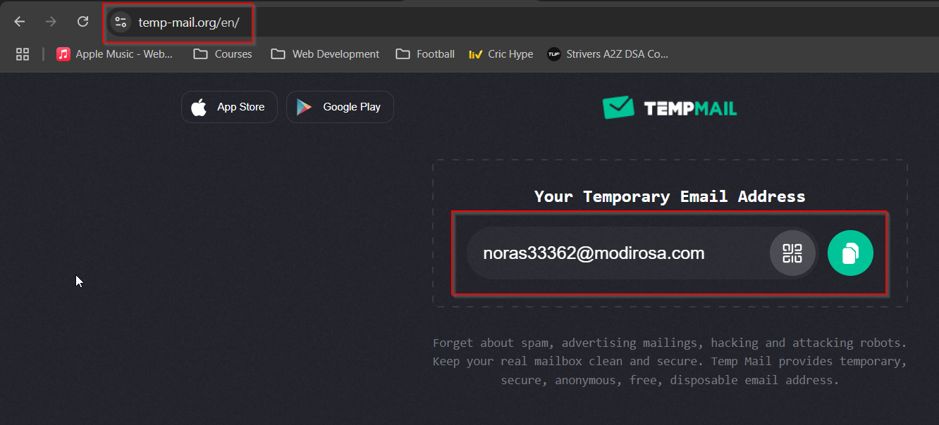

Step 7: Random Indian phone number is generated from <https://randomgenerate.io/random-india-phone-number-generator>

Step 8: A random address is generated from <browserstack.com/free-tools/random-address-generator>

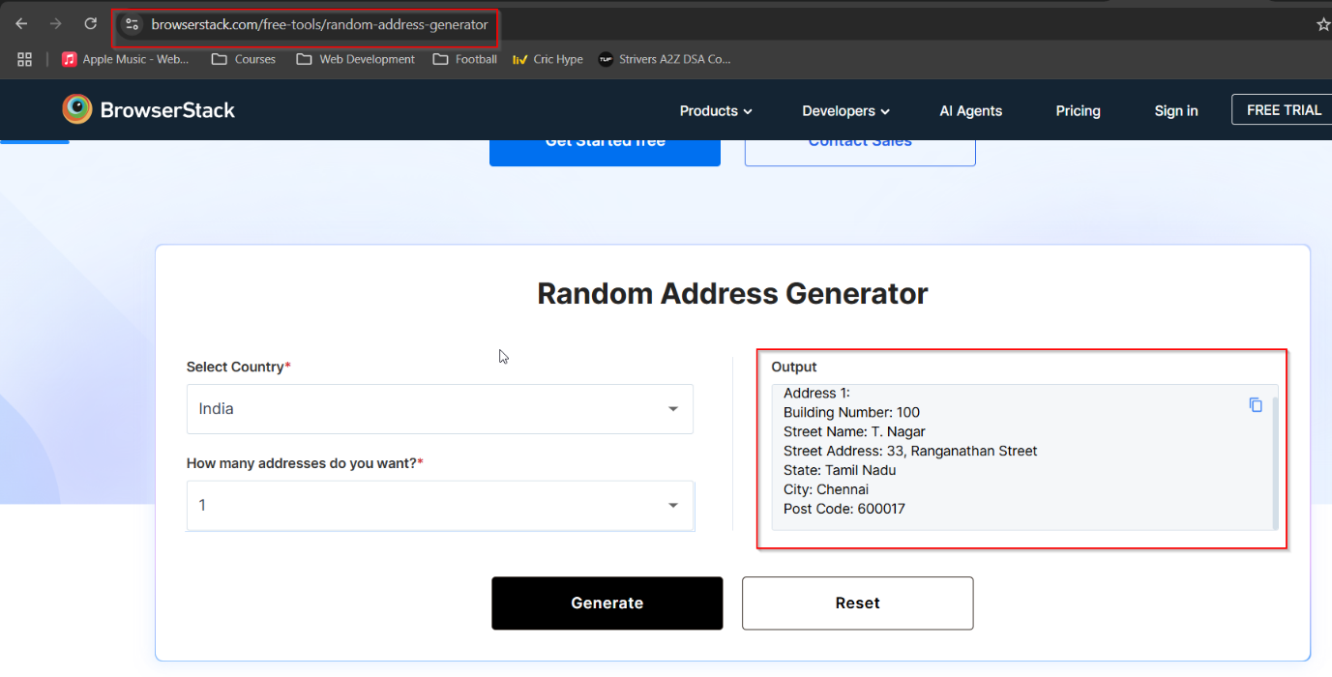

Step 9: Enter all the randomly generated details in the form as shown below

Final Result after signing up:

